Chapter 10: Debugging

Debugging is something that as a programmer you will do every time you sit down at a keyboard. It is not a task that is left until a program is written, it is a process that you must go through many hundreds of times before a program can be completed.
So, what does debugging mean? It is the process of searching out bugs in your code and fixing them. There are a variety of tools available within Visual Studio and we will be looking at these in this chapter. Before we get to the tools, we will first look at the different types of bugs you will encounter.
Bug Type | Description
Syntax Error | Code that will not compile.
Functional Error | Code that compiles but gives unexpected results.
Memory Leak | Program will run for a period of time and then implode.
Table 10.1: Types of bugs

Example: Syntax Errors
Examples of syntax errors are incorrectly spelled keywords or variables and missing semi colons. There are far more reasons for a syntax error, but regardless of the reason Visual Studio will not compile the code and should in most instances give a detailed reason for the issue in the output window. At times, the bug report will not be very helpful and will mean you have got to search for the source of the error yourself. Double clicking on a bug in the output window will take you directly to the area in code where Visual Studio thinks the issue is to be found.
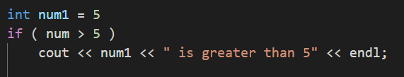
Example: Functional Errors
Examples of functional errors would be the use of a single = when you meant to use ==. This code would compile but would not give the results you expect. These types of bugs can be somewhat more difficult to find as the error might not become immediately apparent. That is to say, everything may run as expected until much later in the program execution.
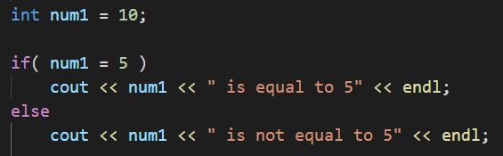
Example: Memory Leaks
When assigning memory, it is vital that you free the memory once you are finished with it. Imagine a function that reserves memory for the task it is about to complete but does not free the memory at the end of the function. This function is then called several hundred times. Eventually your computer will run out of memory and the program WILL crash. We’ll cover these more when we get to Pointers as it these that are the most common reason for memory leaks.
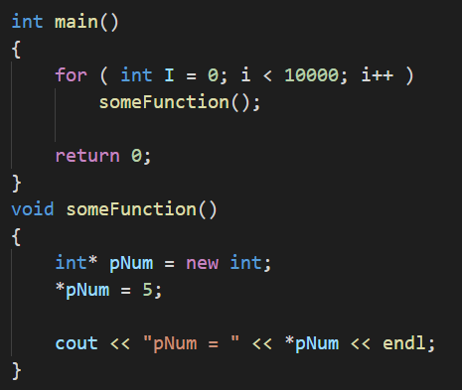

Breakpoints
A breakpoint is a tool that allows you stop your code at run time. This allows you to look at the current values stored in variables and even step through the code and see where it goes.

There are two types of breakpoints that can be used in Visual Studio to help you track down functional errors.
The first and most used is the bog-standard breakpoint. To place a breakpoint simply click in the grey vertical bar that runs down the left-hand side of your code. A red dot should appear. With this in place run your program and you will see that execution is paused when the breakpoint is hit. To remove this breakpoint simply click on the red dot and it will be removed. You can also disable a breakpoint from either the breakpoint window or from the debug menu. To disable a breakpoint means to leave it in place, but to turn it off. It will grey out slightly if disabled. A disabled breakpoint will not stop code execution. If you right click on the red dot you will see that options are presented. From this menu you can add conditions to a breakpoint. For example, if you had a breakpoint within a loop, but you don’t want it to stop until it is on its 20th iteration, you can set this up from this menu.
The second type of breakpoint is a data breakpoint. This type of breakpoint is not placed on a line of code, but rather placed on a memory address. Whenever the contents of that memory address are altered the data breakpoint will stop execution of the code at the line of code that changed the memory. This is useful when allocating your own memory using pointers and you have a particularly difficult bug to track down. To assign a data breakpoint select breakpoints>data breakpoint from the debug menu. You must assign the memory address you are interested in monitoring.
When you have the program paused you can step through your code. The most commonly used functions are to step over a line of code, step into a line of code, or step out of a function. These are all available through the debug menu, the shortcut menu or shortcut keys. Familiarise yourself with these shortcut keys as you will be using them.
Debug Windows
As mentioned above there is a Breakpoint Window. This is where you can manage all breakpoints currently in your codebase. You can even remove them from you code from the breakpoint window.

The Immediate Window is where all local variables are shown. The values stored within these variables are shown to the right of the variable name. Any variable that changes during stepping through code will change red to show you it has changed.
There is a Watch Window available that allows you to add any variable names that you wish to watch. Once added you will be able to see the values of these variables in the same way as the immediate window detailed above.
Program 30: Broken Code
Enter the following program and fix all the syntax errors to get it working. Copy your fixed code in the relevant slot below along with a screenshot of the working program.
Tip: There are 6 errors (the double quotes don’t count if you have copy and pasted) that will stop this program running. Your output may say more, but once these 6 errors are fixed all compounded errors will disappear.
#include <iostream>
int mian()
{
int num1 = 5;
for( int i = 0: i < num1; i++ )
{
cout << “i = “ << i << endl;
}
int num1 = 15;
for( int i = 0; i < num2; i++ ){
cout << “i = “ << i << endl;

/*Pause the output/
cin.get()
return 0;
}

Program 30 Source Code:
Program 30 Screenshot:
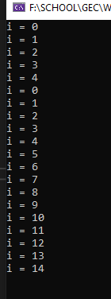
Program 31: Unexpected Code
Enter the following program and fix all the functional errors. This program will run, but it will not give the expected results. Copy your fixed code in the relevant slot below along with a screenshot of the working program.
The expected output is:
1 is an odd number
#include <iostream>
using namespace std;

int main()
{
int count = 3;
for( int i = 1; i > count; i++ )
{
cout << i;
if( count = 2 )
cout << “ is an even number” << endl;
else
cout << “ is an odd number” << endl;
}

// Pause the output
cin.get();

return 0;
}

2 is an even number
3 is an odd number

Program 31 Source Code:
Program 31 Screenshot:
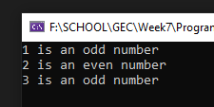
Program 32: Broken BMI
For this program you have been supplied with a cpp file containing code for a quick BMI calculator. The program greets the user, takes their name, and then asks for their weight in stone and pounds, which is then converted into total pounds. Asks for their height in feet and then inches followed by calculating the height in total inches, and finally takes these values to calculate their BMI using the formula of: BMI = $weight*703/{height}^{2}$.
To get started, create a new project and either replace the default cpp file created with the one attached or copy and paste the code across, the choice is yours.
Below you will find a screenshot of the expected output your program needs to replicate, however, within the code supplied there are several errors and some code missing completely. You should be presented with 5 errors in the error list however there is in fact 9 changes to be made including lines of code that are needed.
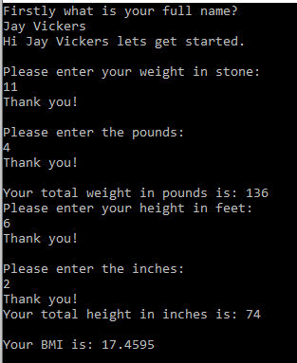
Expected output: Change name and values as you wish.
Program 32 Source code:

Program 32 Screenshot:
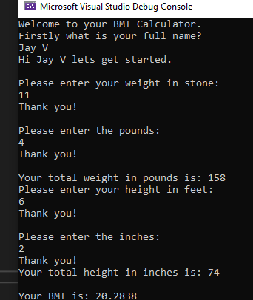
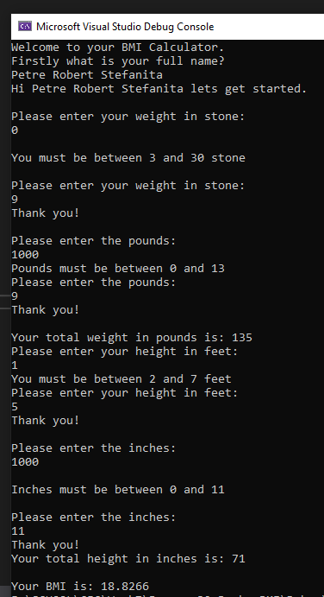

Chapter 11: Structs

At times as a programmer you need to put various data types together into a unified single type. An obvious example would be a 2D position on the screen. This position would be made up of two float data types, one called x, the other called y. How then do we do this then? Well a struct is the answer.
The struct statement will define a new data type that can be used throughout your program. The definition of a struct is as follows:
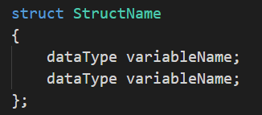
Example: Defining a Struct
Using the position example given at the beginning, we would set this up as:
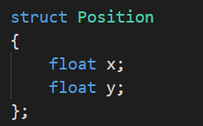
Example: Declaring a variable of Struct data type
Now this creates a new data type, but how do we now use this? We initialise it as we would any other data type. So, to create a variable called characterPosition of data type Position, we could do one of the following:

- Set the variable name as part of the struct statement.
- Or alternatively we can define it alone like so:
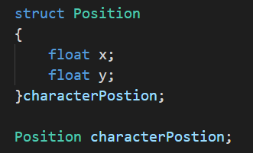
Example: Accessing struct variables
Now have our new data type Position, but how do we get access to the float variables hidden within. Well to do this we use the ‘.’ [dot] operator.
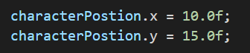
Example of structs and Functions
It is also possible for a struct to contain functions, although this is not so common since the introduction of classes. We will be including functions here for completion sake. The most obvious function to include in any struct is a constructor. A constructor will be called on initialisation and can take parameters to set the internal variables. A constructor must have the same name as the struct name and NOT return any values.
This code snippet shows two constructors for the Position data type. The first takes no parameters and sets the internal variables to zero, the second takes in the starting values with which to set up the internal variables. You can have as many constructors as needed, but they must have different parameters data types for the compiler to know which one to call.
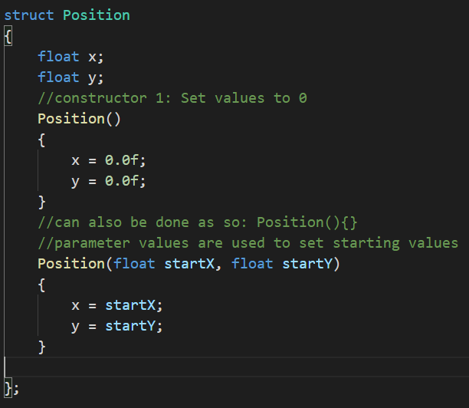
Example: Using constructors with structs
There is a difference when declaring a variable of a struct data type using a constructor and it uses the following format for the first constructor and second detailed above:
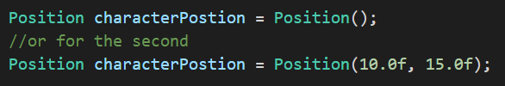

Program 33: Structs
Write a program to prompt the user to enter their name [string], age [int] and telephone number [string]. This is to be stored in a struct data type that you have defined.

Output the struct details to the console using a function defined within the struct definition. Something along these lines:
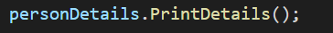
Hint: If you get stuck look at the slides for member functions and possible whitespace issues using cin to string.
Program 33 Source Code:
Program 33 Screenshot:
